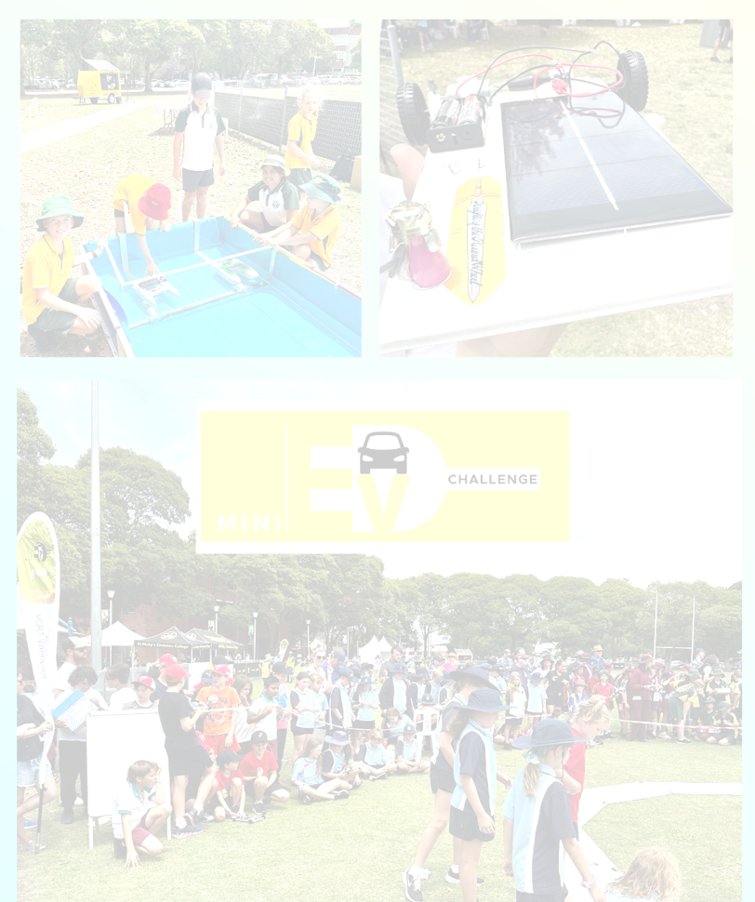

HUNTER MINI EV FESTIVAL

A Unit of Work for Future Teachers  
Solar Boat

**Contents**

Program Overview 3

Teacher Information 3

Syllabus 4

Unit of Work 6

Lesson 1: Design Thinking 6

Lesson 2: Introduction to Solar + Why do boats float? 7

Lesson 3: Research + Empathise 9

Lesson 4 and 5: Define + Research + Generate Ideas 10

Lesson 6 - 8: Make, Test + Evaluate 11

Lesson 9 and 10: Communicate 12

Appendix 1: Resources 13

Learn Kit Library 13

Risk Assessment 13

Competition Details 14

Appendix 2: Bibliography 15

## Program Overview

This document offers teacher resources that can be seamlessly integrated into their existing scope and sequence. This resource has been designed to be integrated into RFF or Library time but may also be used as an in class unit of work for one term for Science and Technology. The program also presents an excellent opportunity to cater for high potential and gifted education focus areas.

Lessons are designed to allow one hour for completion but all lessons could be extended past this if required, or the time table allows. The program is designed to be used in conjunction with the accompanying PowerPoint presentation.

Students will design and create multiple pieces of work during this unit of work, using a variety of resources. At times students will need a computer to support the design thinking process.

Specifically, this resource caters for Science and Technology outcomes, Australian Curriculum Cross Curricular Priorities, Guided Inquiry Learning and Design Thinking Skills. For programs across multiple syllabi with a focus on English and Mathematics, refer to the original ITeach Stem and Future Vehicles resource listed in the bibliography.

All physical resources are available to loan from the Learn Kit Library at Lambton High School. Please contact Peter Melling to organise.

## Teacher Information

Design Thinking is a process of creating and innovating and underpins the development of this teaching program. Students will work through the elements of the design process as shown in Figure 1. Please note this is not a linier process and as the learning in your classroom progresses, students make move back and forth between the elements.

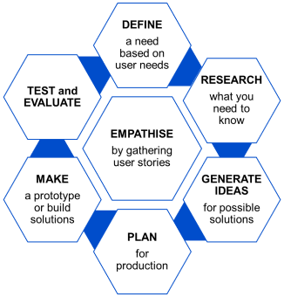

The scientific content of this program is based on an understanding of electrical energy. For additional information on how electrical energy can be transferred and transformed, see NESA Teaching and learning support document: [Stage 3: Knowledge of our world and beyond inspires sustainable solutions](https://curriculum.nsw.edu.au/learning-areas/science/science-and-technology-k-6-2024/teaching-and-learning) p. 6 and 7.

## Syllabus

Please note, this program has been developed to align with the 2024 release of the Science and Technology K-6 Syllabus.

The new Science and Technology K−6 Syllabus (2024) is to be implemented from 2027.

**2025 and 2026** – Plan and prepare to teach the new syllabus

**2027** – Start teaching the new syllabus

[Science and Technology K-6 Syllabus (2024)](https://curriculum.nsw.edu.au/learning-areas/science/science-and-technology-k-6-2024/overview) © NSW Education Standards Authority (NESA) for and on behalf of the Crown in right of the State of New South Wales.

|  |  |  |
| --- | --- | --- |
| **Focus Area** | **Stage 3 Outcome** | **Stage 3 Content** |
| **Science**  Stage 3: Knowledge of our world and beyond inspires sustainable solutions | **ST3-SCI-01**  uses evidence to explain how scientific knowledge can be used to develop sustainable practices  **ST3-PQU-01**  poses questions to identify variables and conducts fair tests to gather data  **ST3-DAT-01**  interprets data to support explanations and arguments | **Electrical energy can be transferred and transformed**   * Recognise that an electrical circuit transfers electrical energy from a source, through a pathway, to a device that transforms electrical energy into other forms of energy * Plan and construct simple electrical circuits to model the transfer and transformation of energy * Pose questions, identify variables and safely conduct fair tests to identify materials that act as electrical conductors or insulators * Explain how electrical insulators can ensure electrical safety in everyday life * Identify renewable and non-renewable energy sources * Research and present information describing the impact on resources and the environment of using a renewable or a non-renewable resource to generate electricity |

|  |  |  |
| --- | --- | --- |
| **Technology**  Stage 3: Design and digital technologies engineer sustainable solutions | **ST3-DDT-01**  uses design processes to create, evaluate and modify designed solutions | **Design processes explore opportunities and develop solutions**   * Research Australian technologies and inventions that meet an identified need * Research how contemporary spaces are co-designed using Aboriginal and/or Torres Strait Islander Knowledge systems and Cultural Practices * Collect data about a user need to generate design criteria for sustainable solutions * Develop design ideas to build a prototype using design criteria * Test, evaluate and modify the prototype to meet the design criteria |
| **Creating written texts in Science and Technology** | **ST3-CWT-01**  creates written texts to communicate understanding of scientific and technological concepts and processes | **Creating written explanations of concepts and processes supports understanding of Science and Technology**   * Use nominalisations to convey scientific and technological concepts and processes succinctly * Add authority to written texts by using data to support an evidence-based explanation or argument * Use compound and complex sentences and labelled diagrams to create a text that explains a process, concept or investigation * Use notetaking, journalling, annotations and labelled images to create a multimodal text that documents the design processes involved in developing a solution * Acknowledge sources of information used in own texts |

## Unit of Work

|  |  |  |  |  |
| --- | --- | --- | --- | --- |
| Lesson 1: Design Thinking | | | | |
| LEARNING INTENTIONS | | **VOCABULARY** | | |
|  | Students will:   * Understand the individual elements of the design thinking cycle * Identify why design thinking is useful * Be curious about the Mini EV competition | * Design thinking * Define * Research * Generate ideas * Plan | * Make * Test * Evaluate * Empathise | |
| LESSON SEQUENCE | | | | **RESOURCES & EQUIPMENT** |
| Introduction to Design Thinking | | | | Slide deck: Solar Boat Lesson Presentations |
| Do: Using the slide deck, introduce the learning intentions and vocabulary for the lesson.  Discuss: Using the slides as prompts (as needed) discuss as a class what design thinking is and why it is helpful.  Do: Use a relevant, contextual, school/classroom example to demonstrate the individual elements of the model. This example should be problem based. For example: At the end of last term, Ms Smith had to move into a new STEM space, all of the resources and equipment have been put in the room but it is not at all ready for student and teacher use. How could we use design thinking to solve the problem? Please note: an example has been included in the slide deck.  Draw conclusions: Using your context based problem, identify how the design thinking model could be used to solve it. | | | |
| Introduction to the Mini EV Competition | | | |
| Do: Introduce the competition using details from the website [here](https://www.hunterevfestival.net) – navigate through relevant tabs.  Create: As a class/group, create a timeline for completion – this will vary significantly based on individual context. An example has been provided in the slide deck. | | | |
| ADJUSTMENTS | | | |
| Enabling prompt: Printed copies of resources for students who may need written details that they can highlight and take notes on. | | | |
| EVALUATION | | | |
|  | | | |

|  |  |  |
| --- | --- | --- |
| Lesson 2: Introduction to Solar + Why do boats float? | | |
| LEARNING INTENTIONS | | **VOCABULARY** |
|  | Students will:   * Understand the basic principles of solar energy production * Identify concepts of buoyancy, density and displacement * Create a clay boat, designed to carry a small weight | * Solar (see slide deck) * Buoyancy * Density * Displacement |
| LESSON SEQUENCE | | **RESOURCES & EQUIPMENT** |
| Introduction to solar energy | | Slide deck: Solar Boat Lesson Presentations  For boat building:   * Plasticine/clay (approx. 200g per group/student) * Small sticks or paper bark * String * Scissors * Container of water * Small pebbles/weights |
| Do: Using the slide deck, introduce the learning intentions and vocabulary for the lesson.  Discuss: Using the slides as prompts (as needed) discuss solar energy/how it works/benefits and limitations. | |
| Why do boats float? | |
| Watch: How taking a bath led to Archimedes’ principle [here](https://ed.ted.com/lessons/mark-salata-how-taking-a-bath-led-to-archimedes-principle).  Do/Discuss: After watching the video, use the THINK and DIG DEEPER tabs on the TED Ed site to discuss the physics of buoyancy and displacement.    Further thinking: Buoyancy explanation [here](https://www.britannica.com/science/buoyancy).  Do: Read and discuss the information and Aboriginal examples of a raft and bark canoe, from the Double Helix article ‘Why do boats float?’  *Adapted from ‘Why do boats float?’ by Sarah Thompson, which first appeared in Double Helix magazine, Questacon Engineering Special Issue, p.24-25. For more hands-on science activities visit doublehelix.csiro.au* | |
| Building Clay Boats | |
| Watch: Clay boat building [here](https://youtu.be/Tc1k-IVIM0U).  Design and build: Using a piece of clay/plasticine, design a boat that will hold a small amount of weight.  Discuss: What is happening? Read and discuss the information, from the Double Helix article ‘Why do boats float? – What is Happening?’  Reflect:   1. As a class/group, share designs and record What worked? What didn’t? 2. Use the THREE-TWO-ONE thinking routine to reflect on the lesson. | |
| ADJUSTMENTS | |
| Extending prompt: Research the long history of Aboriginal and Torres Strait Islander people making boats in your local area.  Newcastle Museum has a display of local Aboriginal and Torres Strait Islander boat in the foyer. See [here](https://newcastlemuseum.com.au/home) for information and opening hours.  An interesting supplementary text could include: *The First Scientists: Deadly Inventions from Australia’s First Peoples by Corey Tutt and Blak Douglas.*  Option: If clay is not available, there are small bamboo serving bowls and bamboo straws available as part of the loan kit library that could be used as a substitute. | |
| EVALUATION | |
|  | |

|  |  |  |  |
| --- | --- | --- | --- |
| Lesson 3: Research + Empathise | | | |
| LEARNING INTENTIONS | | | **VOCABULARY** |
|  | Students will:   * Complete an empathy map to build a deeper understanding of users' needs and wants * Identify the key components of electrical circuits * Be able to create a simple, closed and series circuit | | * Simple circuit * Closed circuit * Open circuit * Series circuit |
| LESSON SEQUENCE | | | **RESOURCES & EQUIPMENT** |
| Please note: If students are working in groups to build their solar boat for the competition, it would be beneficial for these to be formed before this lesson. | | | Slide deck: Solar Boat Lesson Presentations  Empathy Map (one per group)  Paper Circuits   * Paper Circuits Lesson Guide * Copper conductive tape (four 18” pieces per student) * 3mm LEDs (6 per student) * 3-volt coin cell battery (1 per student) * Transparent tape (1 per student or group) * Black permanent marker (1 per student or group) * Paper Circuits Activity Instructions (1 per student) |
| Empathy Map | | |
| Introduce: The quadrants of the empathy map | | **Do:** Each group should complete their own empathy map using the graphic organiser 9with the ‘user’ being themselves! |
| Paper Circuits | | |
| See separate Paper Circuits Lesson Guide. This is a very detailed guide and comprises of several different circuit examples. Activity 1: Simple Circuits and Activity 2: Circuit 1 & 2 will provide students with the knowledge and experience they need to build their boat circuit. The other circuits can be used as an extension task if time permits. | | |
| ADJUSTMENTS | | |
| Extending prompt: [Paper Circuits | Exploratorium](https://www.exploratorium.edu/tinkering/projects/paper-circuits) and [Homemade Switches | Exploratorium](https://www.exploratorium.edu/tinkering/projects/homemade-switches) | | |
| EVALUATION | | |
|  | | |

|  |  |  |  |
| --- | --- | --- | --- |
| Lesson 4 and 5: Define + Research + Generate Ideas | | | |
| LEARNING INTENTIONS | | | **VOCABULARY** |
|  |  | Students will be able to:   * Codesign a problem statement for the design thinking process * Research and analyse boat hull designs * Produce a labelled diagram/s * Collaborate on final hull shape design * Create a template for their boat hull | * Problem statement * Isometric * Labelled diagram * Hull |
| LESSON SEQUENCE | | | **RESOURCES & EQUIPMENT** |
| Define the problem statement | | | Slide deck: Solar Boat Lesson Presentations  Additional information for teachers: [boat_hull_design_kit_ug_56812.pdf](https://asset.pitsco.com/sharedimages/resources/userguide/boat_hull_design_kit_ug_56812.pdf)  Additional information for students:  <https://www.boaterexam.com/boating-resources/boat-hull-types-designs/>  <https://driveaboatusa.com/blog/boat-hull-types-and-shapes/> |
| Discuss: A problem statement helps to provide clarity and a clear focus for designing. As a class discuss and summarise the problem and then use this to define the problem statement.  Record: Your class/group ideas on the slide. An example of what this may look like:  Print and display somewhere prevalent if possible. | | |
| Design Overview + Kit Components | | |
| Discuss: Use the slide deck to discuss   * Design overview * Kit components * Boat hull design, elements and shapes   Watch: [Designing your boat](https://www.youtube.com/watch?v=BOQCYAGa0vI&list=PL2DKUOaVBfxMP9x1tjSvDADGeBazHXkD8&index=6&t=1s) | | |
| Drawing in Three Dimensions | | |
| Tutorial 1. [Sketching a Dinghy and Sailboat](https://vimeo.com/1033203299?share=copy#t=0)  Tutorial 2. [Sketching Motor Yacht and Cruise Ship](https://vimeo.com/1036487214?share=copy#t=0)  Tutorial 3. [Sketching Pilot boat and Container Ship](https://vimeo.com/1036492462?share=copy#t=0) | | |
| Hull Template | | |
| Watch: [Hull template for solar boats](https://www.youtube.com/watch?v=hHFNZRS4uO0&list=PL2DKUOaVBfxMP9x1tjSvDADGeBazHXkD8&index=2) | | |
| EVALUATION | | |
|  | | |

|  |  |  |  |
| --- | --- | --- | --- |
| Lesson 6 - 8: Make, Test + Evaluate | | | |
| LEARNING INTENTIONS | | **VOCABULARY** | |
|  | * Jointly construct goals for the three lessons | * N/A | |
| LESSON SEQUENCE | | | **RESOURCES & EQUIPMENT** |
| Goal setting | | | Slide deck: Solar Boat Lesson Presentations  Solar boat kits |
| Discuss: Jointly construct based on the amount of time/lessons you have allocated for building, testing and evaluating. This should then be displayed so students are able to self-regulate and manage their time to produce their final boat design in the time allocated.  Review: Competition [guidelines](https://www.hunterevfestival.net/page/display/id/19) and watch [this example](https://www.youtube.com/watch?v=hQq8pfETxnc&list=PL2DKUOaVBfxO8ROKxTCbjHFZuQS-IqmLB&index=3) of the boat race. | | |
| Video Tutorials | | |
| These video tutorials may be useful for students and teachers before beginning the build:   * [Shaping your boat](https://youtu.be/XqMx67ezmoE?si=CpY3dhlH4fxi5pmS) * [How to build your boat circuit](https://youtu.be/SmQfMLt_OYc?si=AUboXC1xA8K67q-t) * [Guides for your boat](https://youtu.be/z4R2mh99nN4?si=PPUibr14op80U0MD) | | |
| Build, Test + Evaluate | | |
| Now is your time to build, test, evaluate and rebuild as many times as you need to!  Think about environmental factors that impact performance 3D print options: guidance system, wheels, chassis, anything else you can imagine! | | |
| EVALUATION | | |
|  | | |

|  |  |  |  |  |
| --- | --- | --- | --- | --- |
| Lesson 9 and 10: Communicate | | | | |
| LEARNING INTENTIONS | | | **VOCABULARY** | |
|  | Students will be able to:   * Create a written text to communicate the design process of creating their solar boat * Create a labelled diagram to communicate their final design * Reflect on their thinking and learning | | * Various from throughout unit | |
| LESSON SEQUENCE | | | | **RESOURCES & EQUIPMENT** |
| Communicate | | | | Slide deck: Solar Boat Lesson Presentations  Devices for digital creation if required  Copy of learning reflection (one per student) |
| Students create a one-page overview (handwritten or digital) to communicate the process of designing and building their solar boat. Their design should communicate the different elements of the design thinking cycle and include a detailed labelled diagram.  If time permits or students need further extension, they may wish to use a more detailed communication platform such as a pitch deck, virtual learning environment, website, infographic or instructional video. | | | |
| Battle of the boats | | | |
| Create a draw for your teams to battle each other before deconstructing their boats! | | | |
| Reflection | | | |
| Encourage students to think about:   * The whole process – from your original concept sketch to the final build * Modification and changes you had to make (to your design and your thinking) * How you worked as part of a team – your cooperation and commitment * The actual race day | |  | |
| EVALUATION | | | |
|  | | | |

# Appendix 1: Resources

## Learn Kit Library

|  |
| --- |
| **Available Resources** |
| * Boat kit * Class set of Splats * Curriculum program and accompanying digital files * Blow up paddle pool * Bamboo straws * Bamboo serving trays |
| **Additional Useful Tools** |
| * Craft right junior hacksaw (or equivalent) * Metal files (for shaping) * Sand paper (for shaping) * Safety goggles and gloves (if required for Risk Assessment compliance at your school |

## Risk Assessment

Included as separate document.

Please note: this will need to be reviewed and updated for your personal school context and sta

## Competition Details

Updated 2025 competition details not available at time of publication.

Please check the [Hunter Valley Mini EV Challenge 2024](https://www.hunterevfestival.net/) website for 2025 dates and guidelines.

# Appendix 2: Bibliography

This program was developed by Abbey MacPherson, if you have any questions or feedback, please contact [Abbey.MacPherson1@det.nsw.edu.au](mailto:Abbey.MacPherson1@det.nsw.edu.au)

This document would not exist without the following resources:

[Home | NSW Education Standards](https://educationstandards.nsw.edu.au/wps/portal/nesa/home)

<https://www.kitesite.com.au/>

<https://www.hunterevfestival.net/>

<https://iteachstem.com.au/wp-content/uploads/2020/10/iSTEM-solar-car-project-v2.docx>

<https://education.nsw.gov.au/teaching-and-learning/curriculum/stem/early-stage-1-to-stage-3/stem-units-of-work/future-vehicles>

‘Why do boats float?’ by Sarah Thompson, which first appeared in Double Helix magazine, Questacon Engineering Special Issue, p.24-25. For more hands-on science activities visit doublehelix.csiro.au